Computer Hacking Forensic Investigator (CHFI) Project

CCCY 422

Submitted by:

1. Lara Alofi 2110886
2. Taif AlQarni 2111092

30\11\2024

Lab Session Identifiers

1. https://labclient.labondemand.com/LabClient/92f00cca-ce4b-4b26-ba11-2289cc5a3759
2. https://labclient.labondemand.com/LabClient/980daf65-7857-4410-b871-40d47a060412

Username on EC-Council System

1. 2110886@uj.edu.sa
2. 2111092@uj.edu.sa

Part [I]

**Module 09:** Malware Forensics

**Lab 1:**

**Lab 2:**

**Lab 3:**

**Lab 4:**

**Lab 5:**

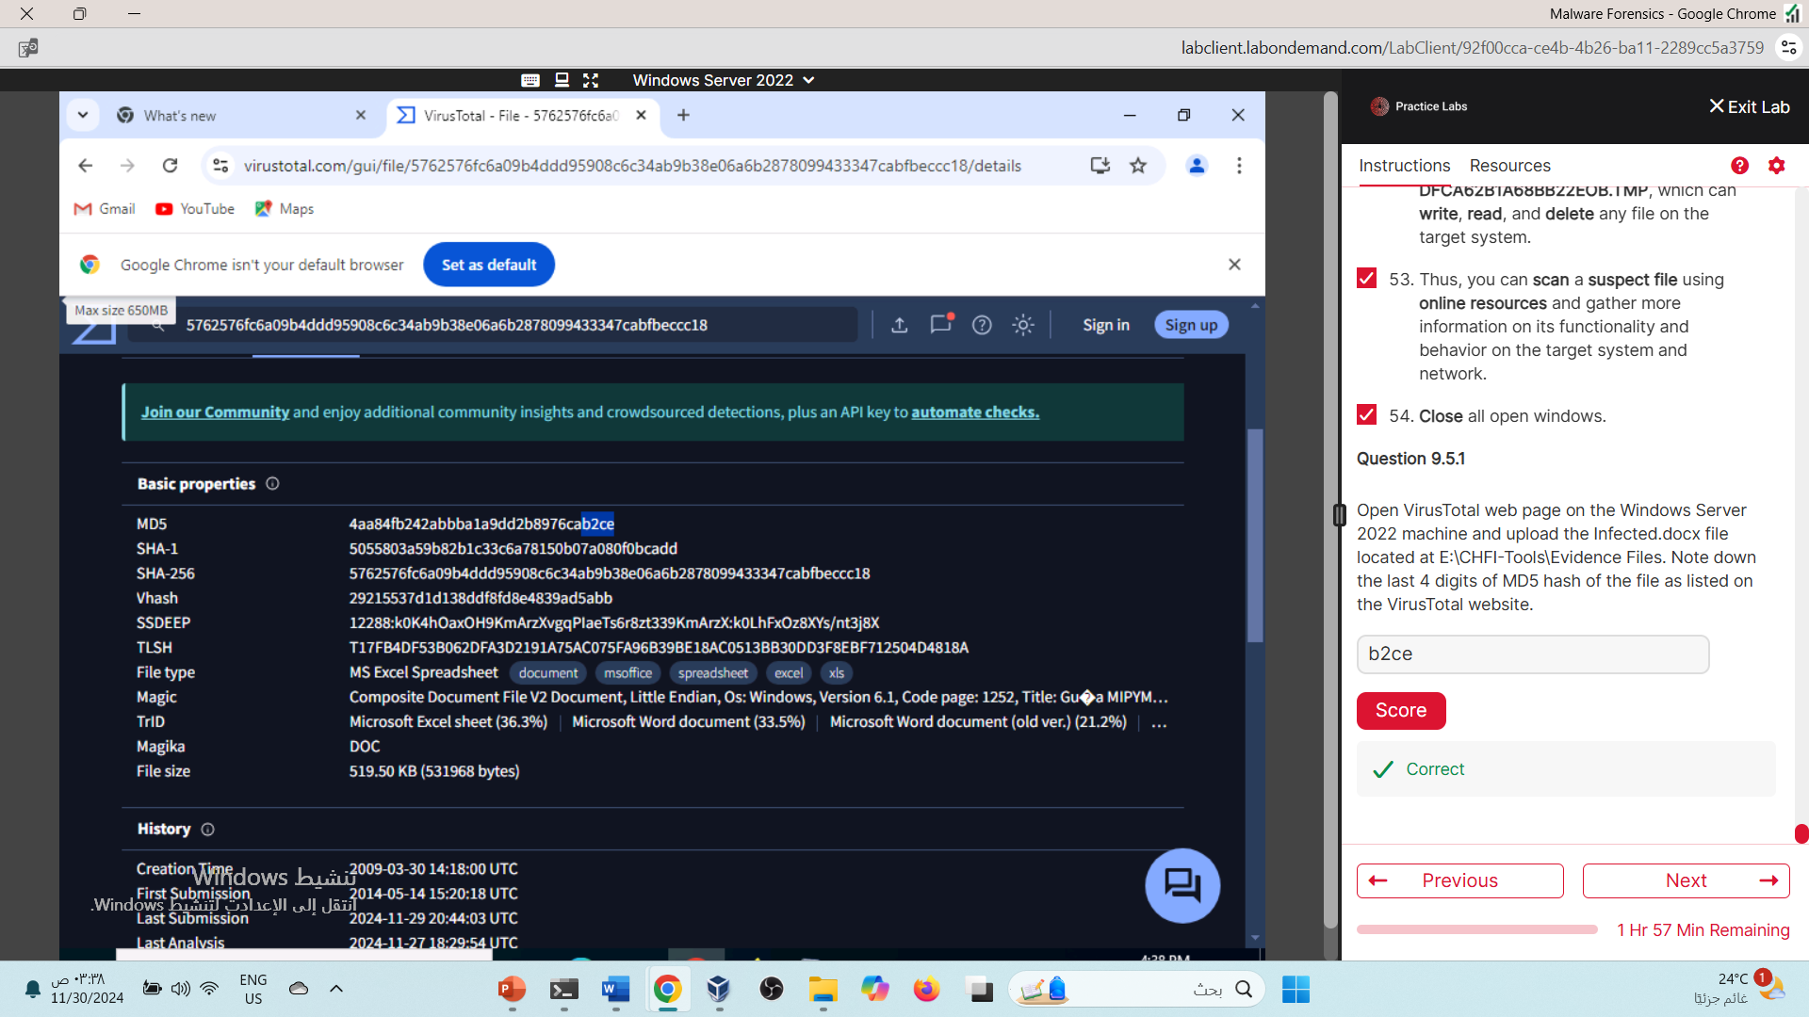

**Lab 6:** 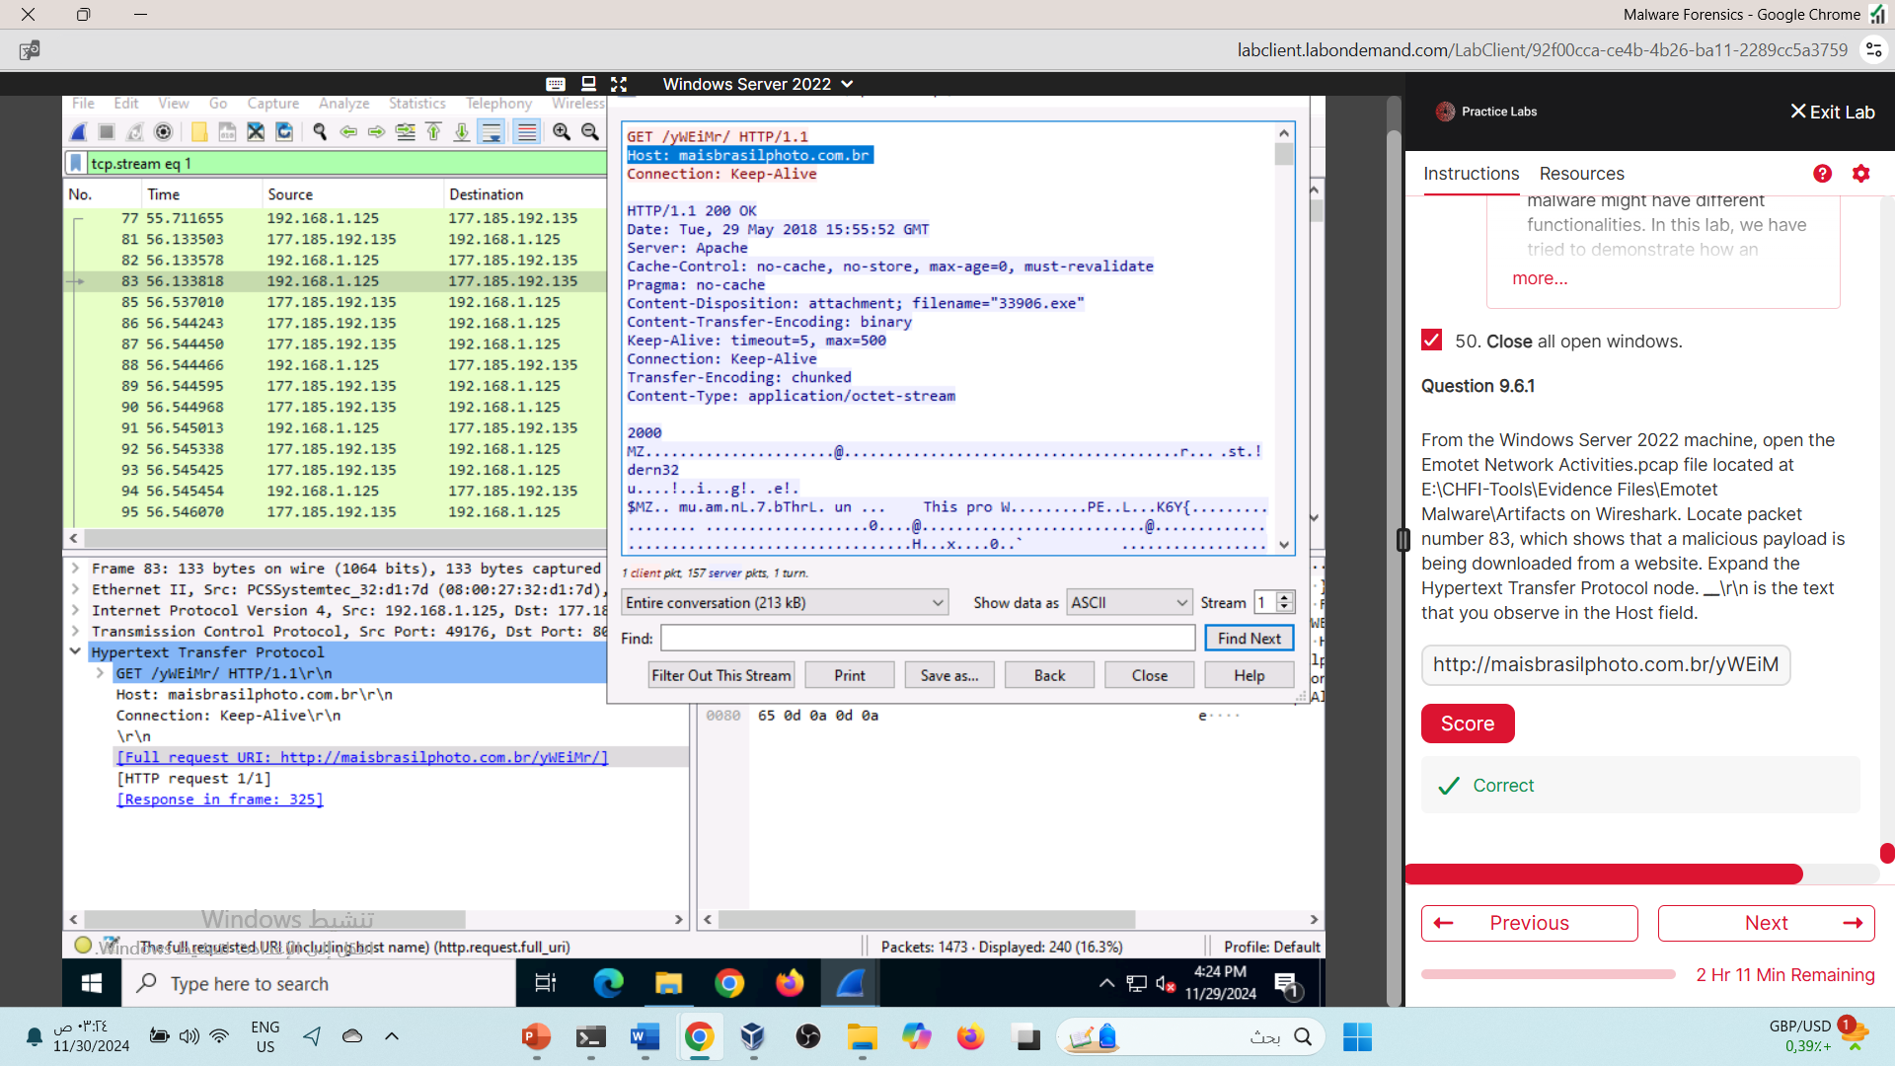

**Lab 7:**

Part [II]

**Module 13**: Email and Social Media Forensics

**Lab 1:**

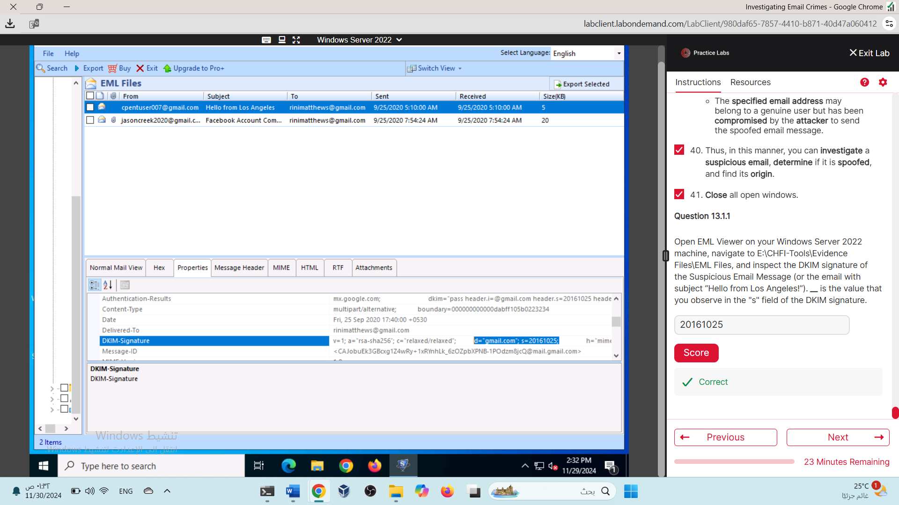

**Lab 2:**

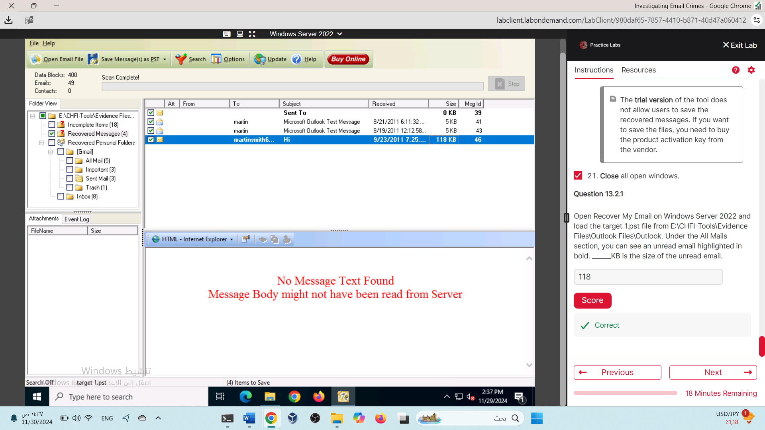

**Lab 3:** 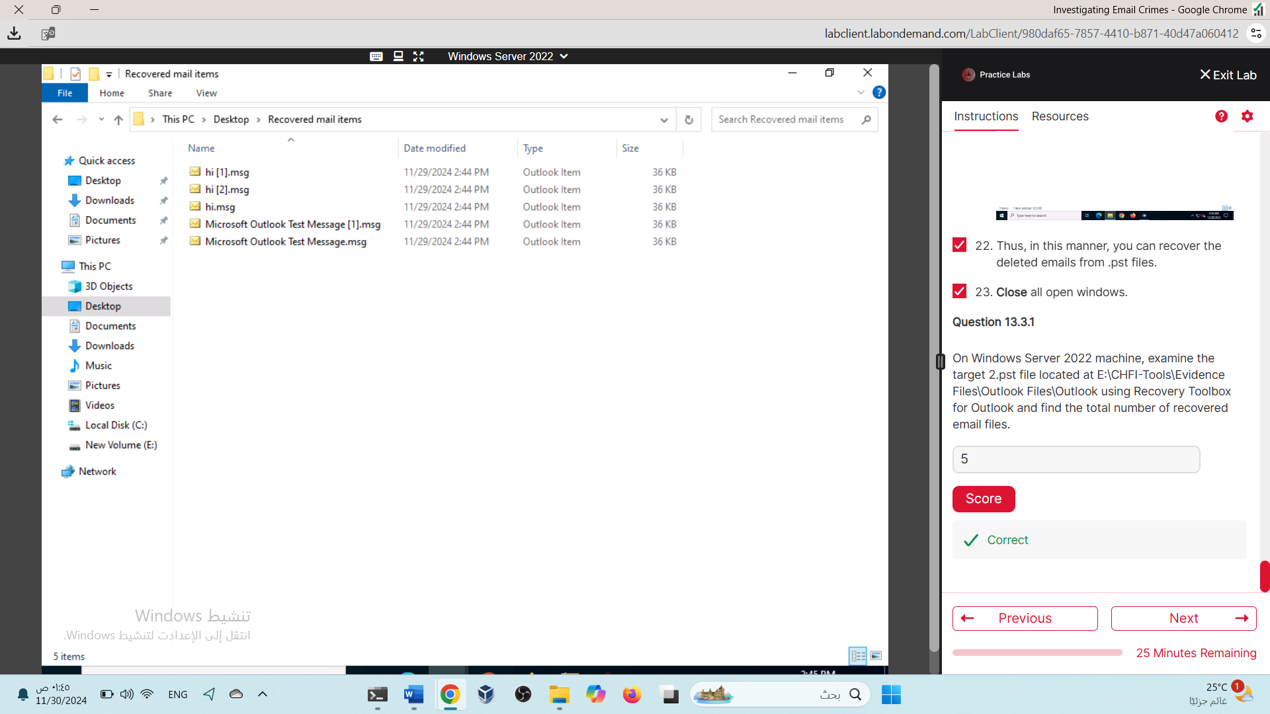

**Lab 4:** 